**Website Specifications:**

1. State the website objective, its goals in relation to the business.

* This is a fantastic and original concept for a website This websites goal is to speak to moviegoers who, regardless of the cast, are always pressed for time and rush to download or view new releases. This website was designed using desktop programs, Python libraries, and basic math operations. Anyone may utilize the program, which eventually aids them in making the decision of whether or not to view the movie.

1. State the target audience, showing their demographics and technical aptitude.

* The target market follows young teens, young adults, and kids on the basis of genre all over the world. They are young and affluent, with high disposable incomes. They are avid watchers, into, movies technology and lead busy and active lives making them difficult to target with other media.

1. You must identify the type of website or content you will be designing for the users

* A movie theatre website will be created as to advertise movies : Images will be available as logo, movie banners , home page cover and short videos as trailers for the movie.

**Information Design & Taxonomy:**

SUB PAGE

SUB PAGE

SUB PAGE

SUB PAGE

FEEDBACK

COLLECTIONS

APPS AND GAMES

TV SHOWS

MOVIES

HOME PAGE

WARNER BROS

**Page Template Design:**

***WEBSITE WIREFRAME***

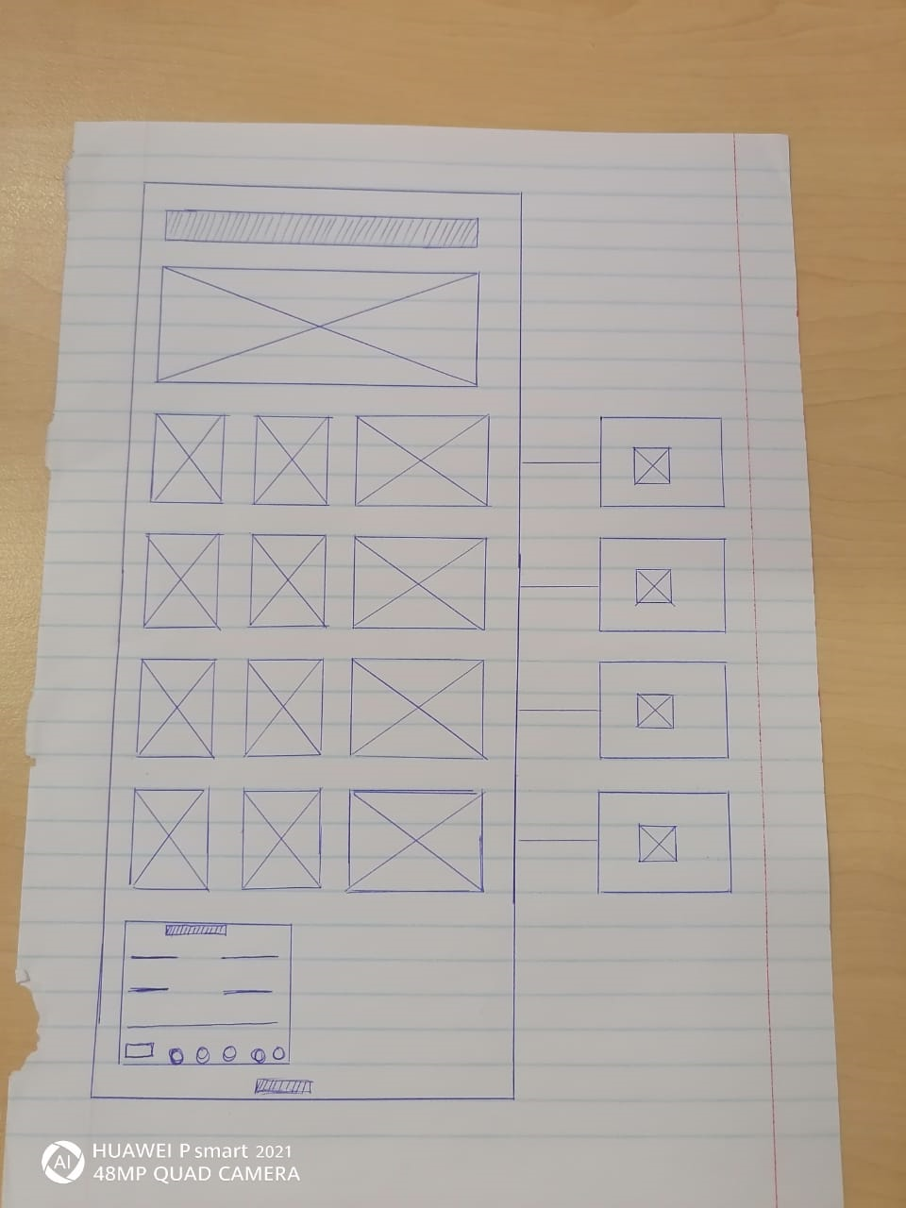

HOME PAGE

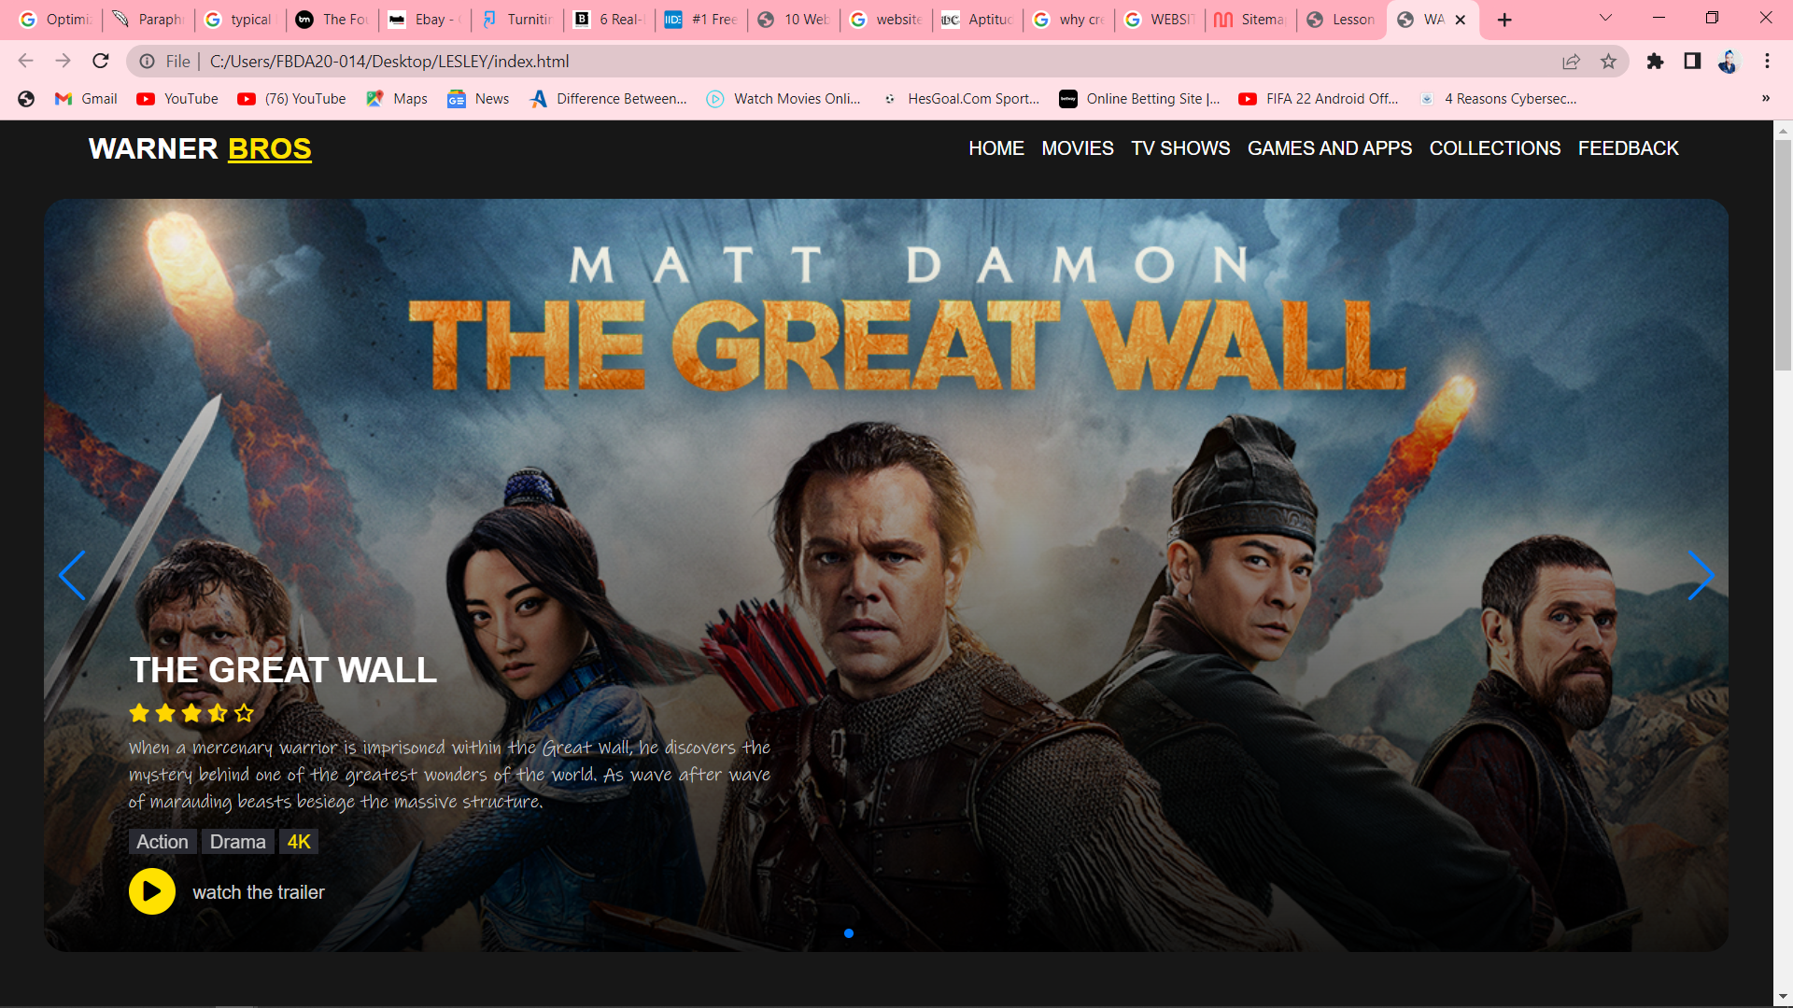

MOVIES PAGE

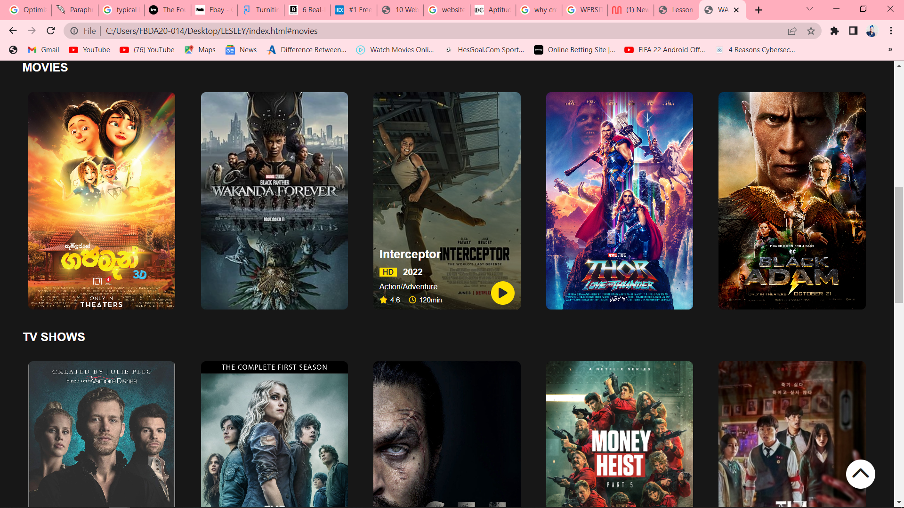

MOVIE SUB-PAGE

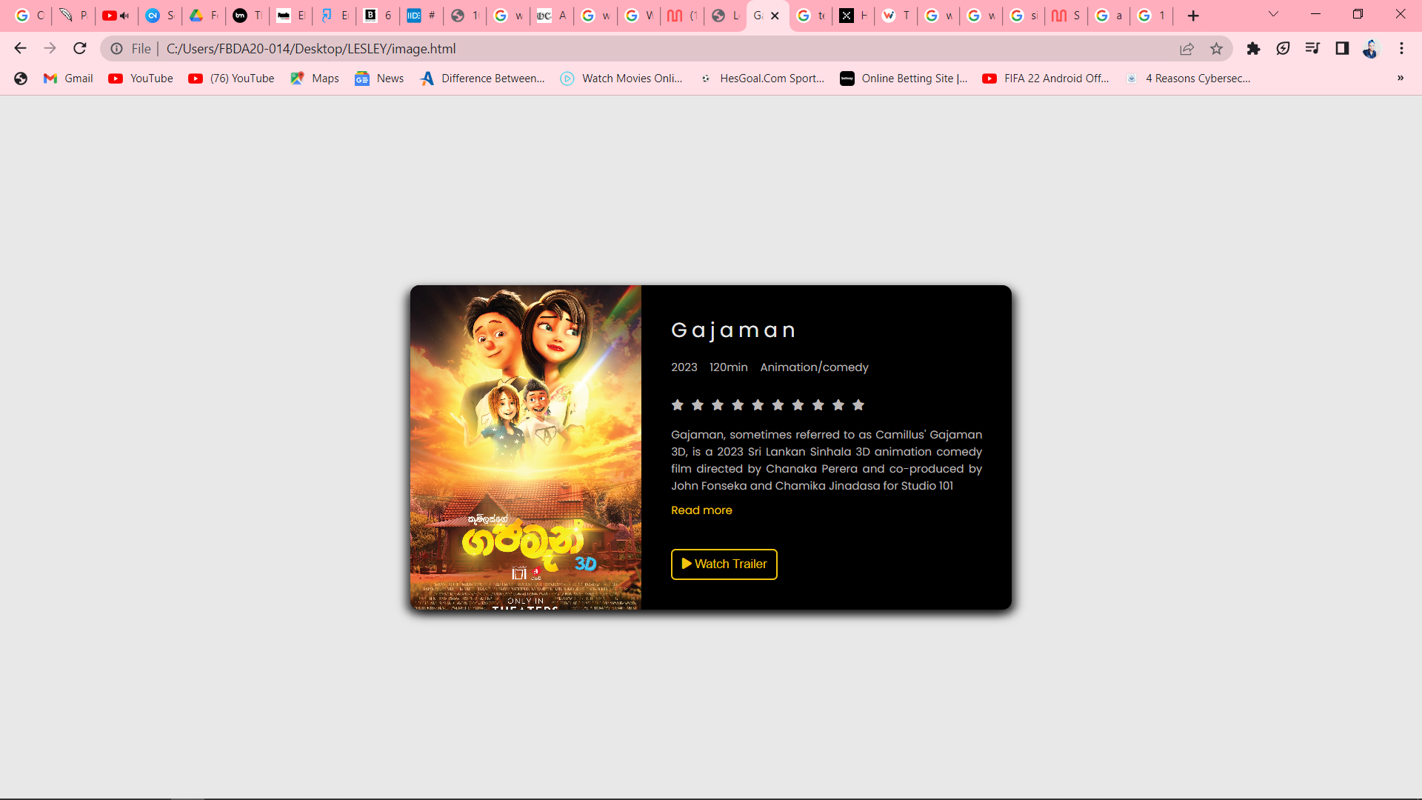

TV SHOWS PAGE

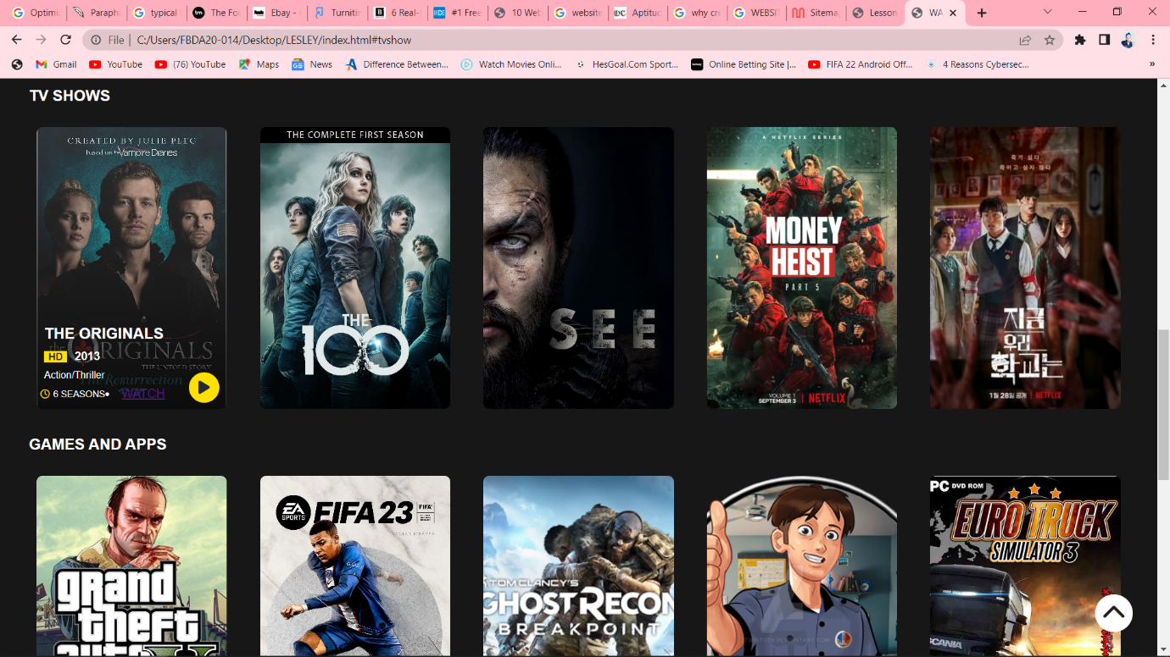

TV SHOWS SUB-PAGE

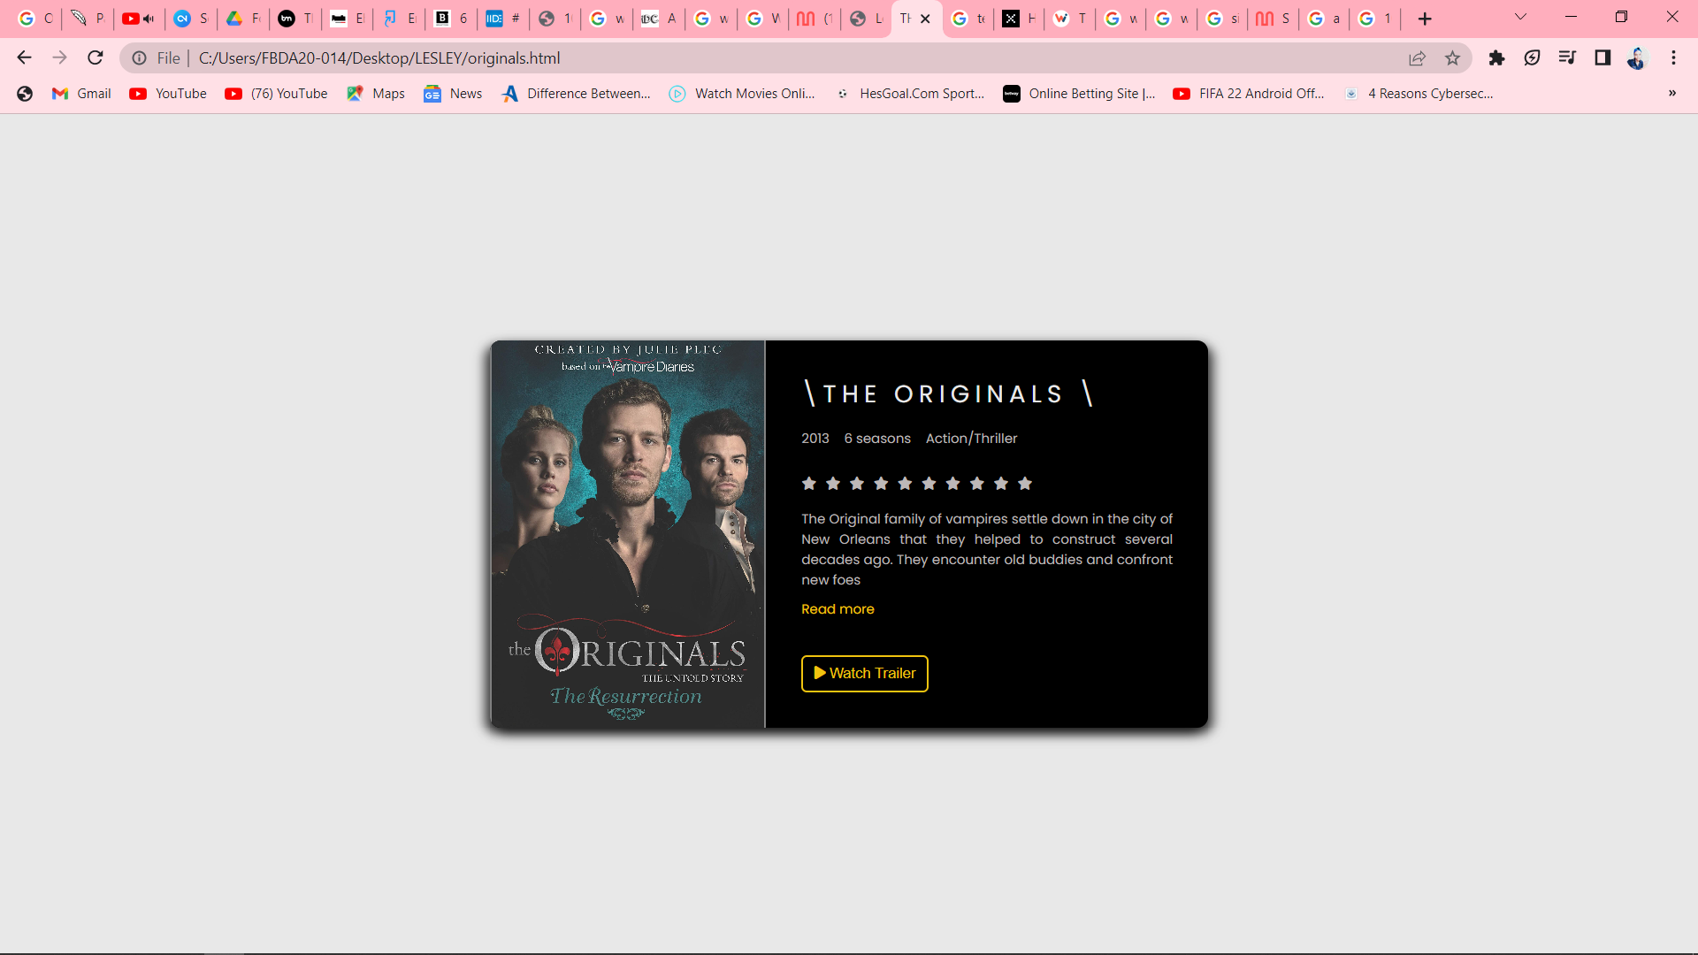

GAMES AND APPS PAGE

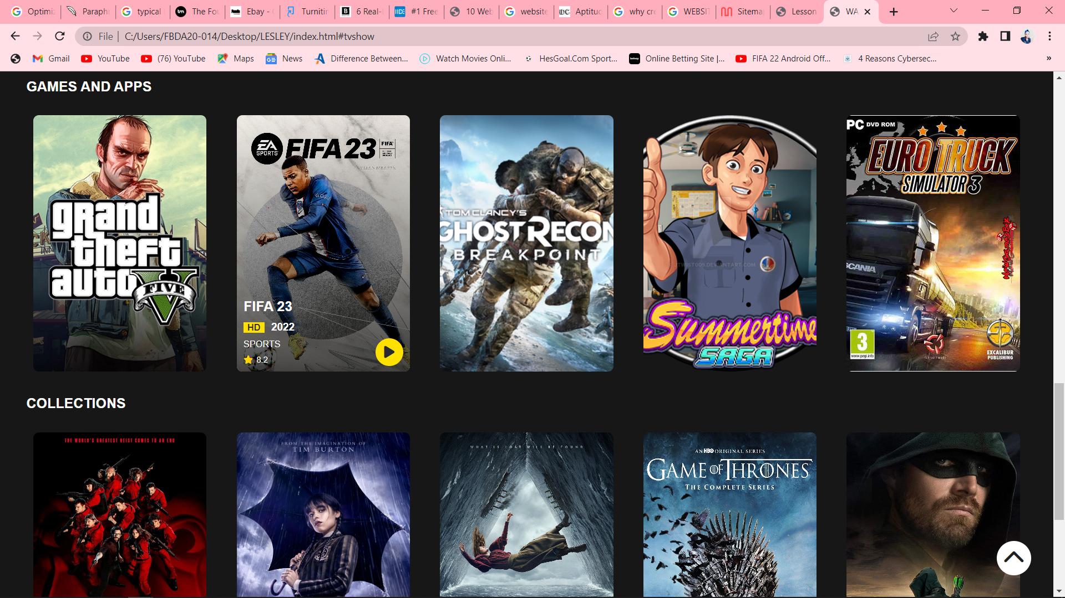

GAMES AND APPS SUB-PAGE

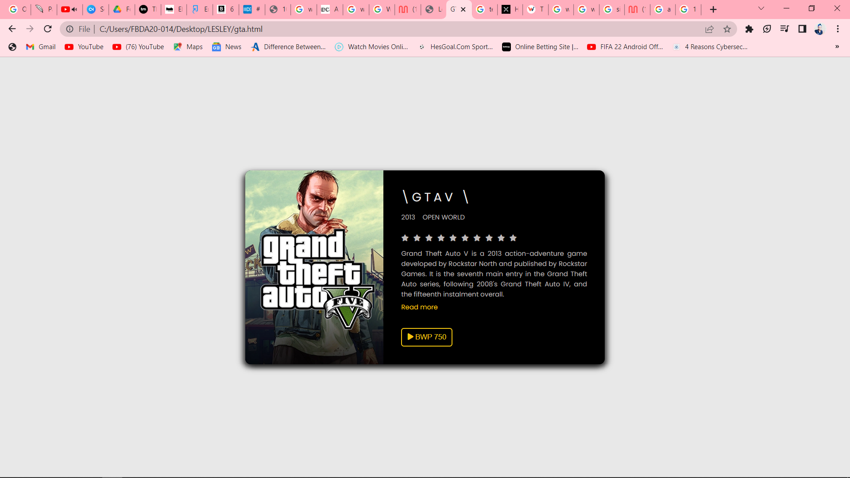

COLLECTIONS PAGE

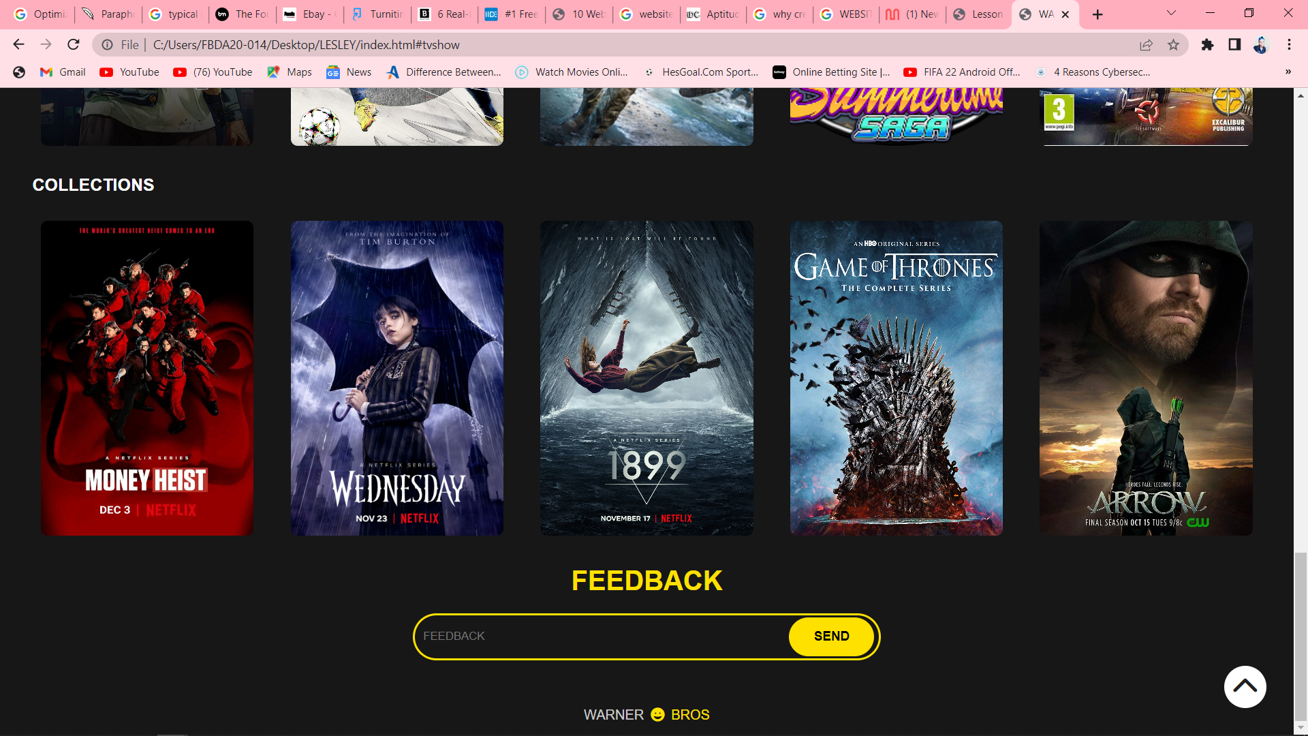

COLLECTIONS PAGE SUB-PAGE

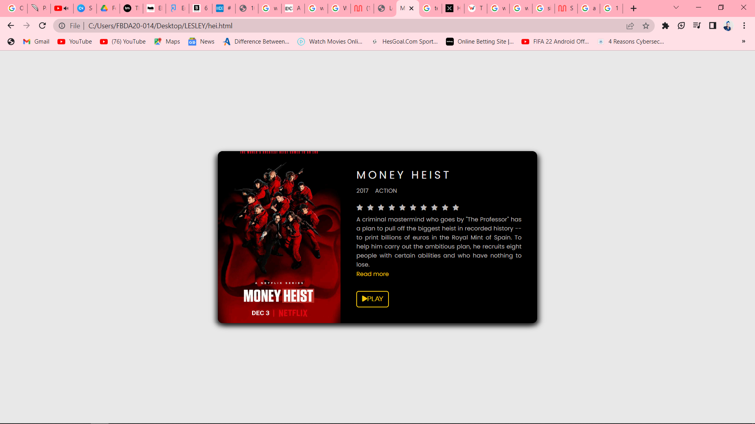

FEEDBACK PAGE

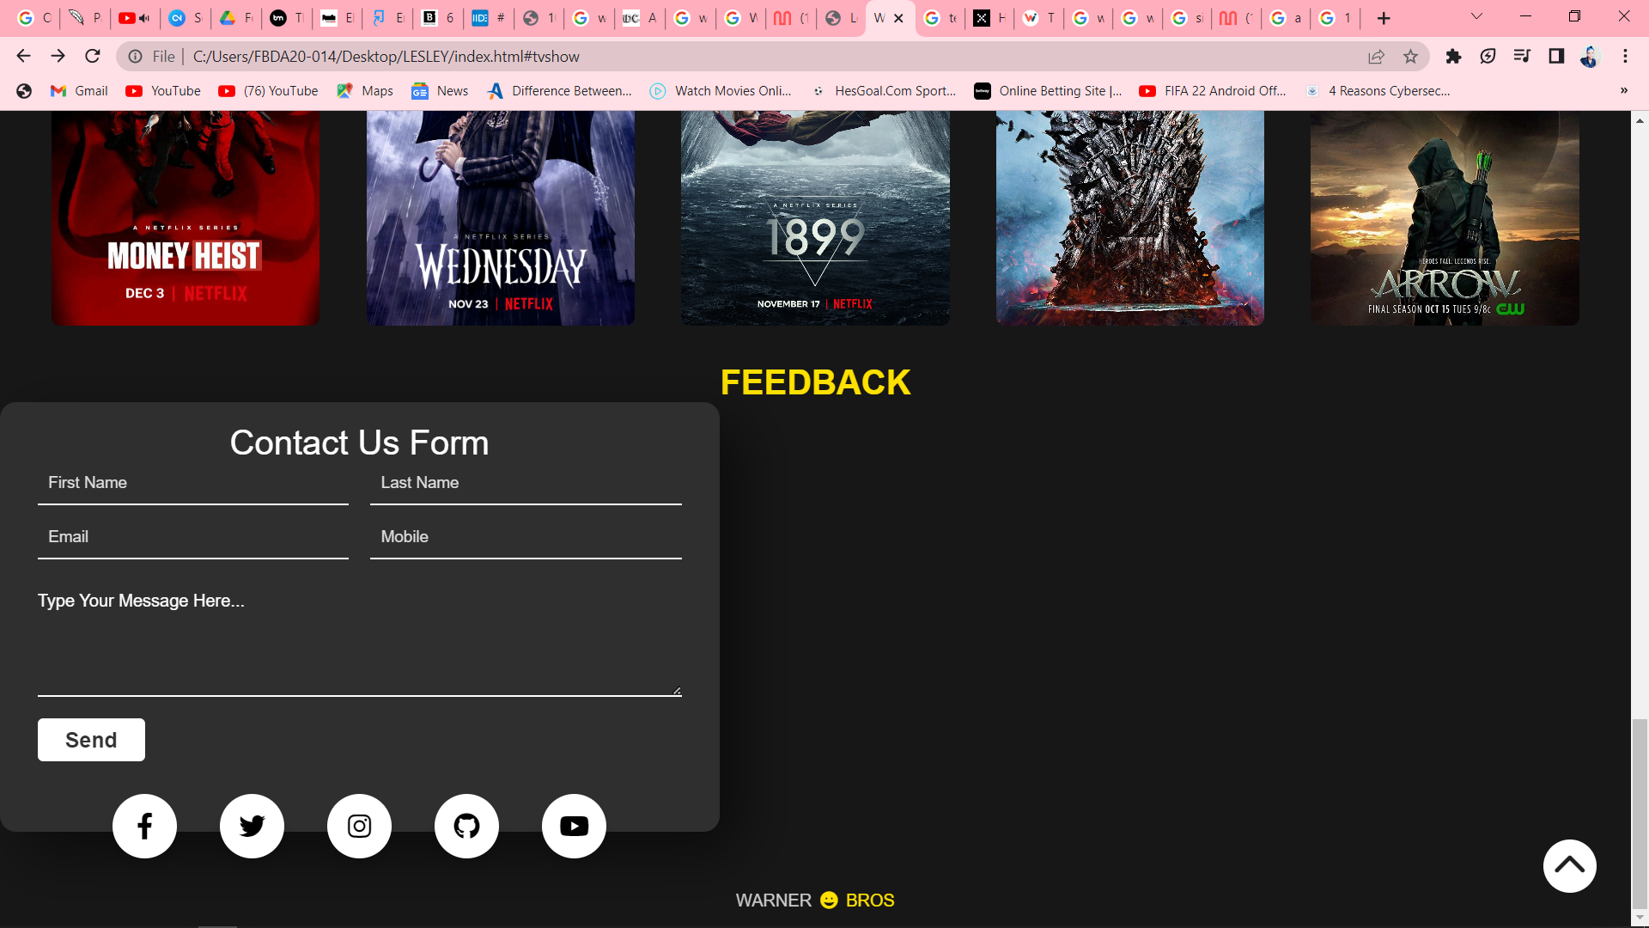

**Technical Brief:**

The technologies to be in use for completion of the websites will be the notepad for coding , gimp for banners to be used in the websites. External links will be used as to link my buttons to where the trailer videos will be available. The Hyper Text Markup Language will be used for describing the structure of the web pages as CSS will be used to define the appearance of the markup. Google chrome will be used as the interpreter of the website. Programming language as java will be used to create more dynamic interactions. Protocols as HTTP to be used as this protocol requests the website from Google’s server and then receives a response with the HTML, CSS, and JavaScript of the website.

**Quality Assurance**

THE WEBSITE WAS TESTED ON GOOGLE CHROME

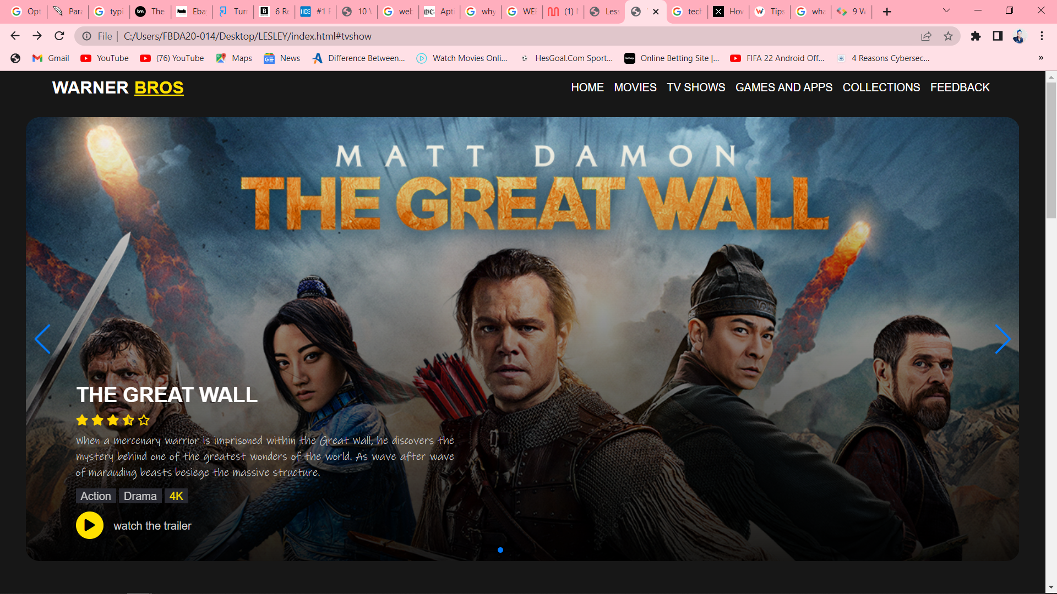

**THE WEBSITE WAS TESTED ON MICROSOFT EDGE**

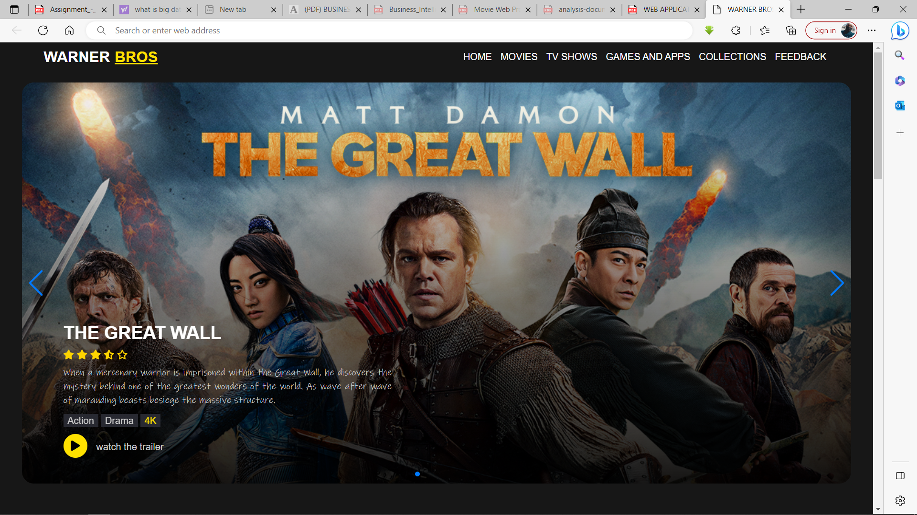

**MOBILE DEVICES**

**HUAWEI P SMART 2021**

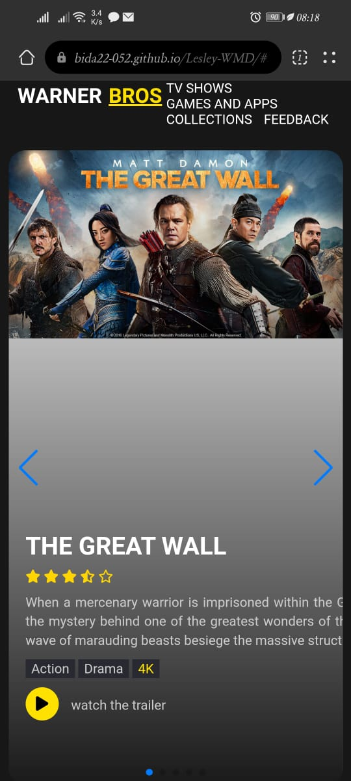

**SURFACE PRO 7**

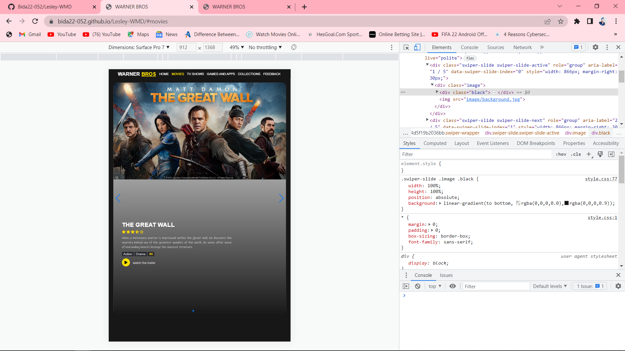

**LESLEYS PHONE**

**Publishing & Promotion:**

**https://bida22-052.github.io/Lesley-WMD/**

GitHub Pages is a static site hosting service that publishes a website from HTML, CSS, and JavaScript files that are directly pulled from a repository on GitHub. Three steps can be used to sum up the process of using GitHub Pages to host a website:

* Register for a GitHub account.
* Set up a new repository with some guidelines.
* To launch your website, make changes to your code and upload them to GitHub. A link will be generated.

For promotion :

* Social media: The most well-known free strategy for promoting new websites is social media, and for good reason. With billions of users across platforms like Facebook, Twitter, and Instagram, connecting with other local businesses and promoting your own is simple.
* Content marketing: Because content marketing boosts my SEO and creates content that readers will find useful, it's a great way to promote my website. Contrary to popular belief, one does not necessarily need to blog to engage in content marketing. Even though blogs are the tried-and-true method of content marketing, i can make videos, start a podcast, or even launch a newsletter about a topic related to my line of work.

**Future Developments/Recommendations:**

1. **Testimonial Pages**

No one is going to look at my "Testimonials" page, that much is clear.

If I have great clients who have good things to say about my website, it's fantastic and should be seen. The best way to do this is to disperse it across my website. If possible, add case studies or video reviews there or on product pages.

1. **Thank You Page**

It is one of the most underutilized methods of engagement that is also simple to use. On thank you pages, I can ask visitors to download my game, subscribe to my newsletter, get a coupon code, or follow me on social media.